|  |  |
| --- | --- |
|  | **FPT ACADEMY INTERNATIONAL**  **FPT – APTECH COMPUTER EDUCATION** |

**Centre Name: ACE-HCMC-2-FPT.**

**Address: 590 Cach Mang Thang 8, District 3, Ho Chi Minh City, Viet Nam.**

**PLEASANT**

**TOUR**

|  |  |  |
| --- | --- | --- |
| **Supervisor.** | PHAM THI LANH | |
| **Batch.** | T1.1806.M0 | |
| **Group.** | 5 | |
| **Serial No.** | **Enrollment Number** | **Student Name** |
| 1. | NGUYEN VAN LAM | Student1205750 |
| 2. | NGUYEN VIET DUNG | Student1198490 |
| 3. | PHAM LE HOANG MINH | Student1198489 |
| 4. | NGUYEN NHAT TAN | Student1198574 |

Month 9 Year 2019

This is to certify that:

Mr: Nguyen Van Lam

Mr: Nuyen Viet Dung

Mr: Pham Le Hoang Minh

Mr: Nguyen Nhat Tan

Has successfully Designed & Developed

**PLEASANT TOURS**

Submitted by:

Pham Thi Lanh

Date of issue:

September, 20th 2019

Authorized Signature:

**Table of contents**

**Acknowledgement** 4

**Synopsis** 5

**REVIEW 1** 6

Requirement Specification 7

Problem Definition 8

Customers requirement specifications (CRS) 9

Architecture and Design of the System 10

Sitemap 11

Website Layouts 12

**1.** **Home** 12

**2.** **Informative pages of Adventure Tours, ….** 14

**3.** **Detail Tour for all Tours** 16

**4.** **About Us and Contact Us** 18

Task Sheet 1 21

**REVIEW 2** 22

Website Interface 23

**1.** **Homepage** 23

**2.** **Contact Us Page** 28

**3.** **About Us** 29

**4.** **Type Of Tour** 32

**5.** **Footer** 34

Time Management 36

Task Sheet 2 37

Checklist Validation 38

Referrence 39

# **Acknowledgement**

I would like to acknowledge all those who have given moral support and helped in making the project a success.

I wish to express my gratitude to the e-Projects Group at the Head Office, who guided and helped me. I would also like to express my gratitude to all the staff members of my center for not only providing me with the opportunity to work with them on this project, but also for their support and encouragement throughout the process.

I also express my sincere gratitude to the e-Projects Team at the Aptech Head Office and my project guide at the organization, for her valuable guidance and support for the completion of this project.

And finally, I would like to offer many thanks to all my colleagues for their valuable suggestions and constructive feedback.

# **Synopsis**

Pleasant Tours has been a popular type of travel in many countries since 2000, now StarTravels wants to completely change their current website. The website they require can provide user-friendly environment and navigation.

The important menu must be stated in the top section of the webpage. Also a decent look out and color combination is expected.

The website is to be developed for the Windows Platform using HTML5, JavaScript and Geolocation. The site should work well in all leading browsers including Chrome, IE, Firefox..

# **REVIEW 1**

## **Requirement Specification**

The Web site is to be created based on the following requirements.

1) The Home Page should be created making use of Frames with a suitable logo.

2) The site should display a menu which will contain the options for brief introduction about the various products available, location of the shop and any other information if required.

3) The information should be categorized according to different type of products like if a User wants to see only ‘Beach Tours’ then he click on a Link/button/menu etc and he will see different type of Beach Tours. Similarly for ‘Hill Stations’, ‘Forts/Palaces’ and other products.

4) When a user selects any product type, a list of products for that product type will be displayed.

5) Itinerary of individual tour products should be displayed on the Web Page along with the title but detailed itinerary should be stored in Individual Word documents which can be downloaded or viewed by the User who wishes to see the same.

6) Price List for all tours should be available for download.

7) There should be a “Contact Us” page which will have the Address of the Company which is as follows and the mail address which when clicked will invoke the local mail client from where they can send an email. Address of the Company should be displayed using GeoLocation API (eg. GoogleMaps).

**Problem Definition**

After reading the project specifications, the developer states the scope of the project very briefly. This is referred to as the problem definition. Queries of various staff members can be one or all of the following:

1. How many tours can be displayed on Homepage at a time?
2. What information should be displayed about each tour in Homepage?
3. What requirements and questions can users contact support?
4. Will users be able to rate with their comments?
5. Will users be able to ask questions about the service of Startravels?

After consulting several IT companies and considering the budget constraints, the management of StartTravels to launch the Web application as a single page responsive Web application using HTML5, CSS3, JavaScript, Geolocation API, and Bootstrap from getbootstrap.com, jQuery plugins, and Coffee Cup, Notepad++, or other HTML editor. Also, the site will be tested on popular browsers(Ex: Chrome, IE, Firefox etc.) and mobile emulator software.

## **Customers requirement specifications (CRS**)

**1. Client:** StarTravels .

**2. Business/Project Objectives:**

➢ Provide a website to displays the programs and services about tours such as: “Home”, “Type of Tour”, “About”, …

➢ Enable customers to see what event that they would like for easier interactive with us.

**3. Inputs provided by clients:** Inputs to the existing system. Outputs from the existing system. Process involved in the application. Expected delivery dates. List of deliverables.

**4. Hardware Requirement:**

- A minimum computer system that will help you access all the tools in the courses is a Pentium 166 or better

- 64 Megabytes of RAM or better.

**5. Software Requirements:**

- Notepad/HTML editor

- Dreamweaver

- IE 5.0/ Netscape 6.0

## **Architecture and Design of the System**

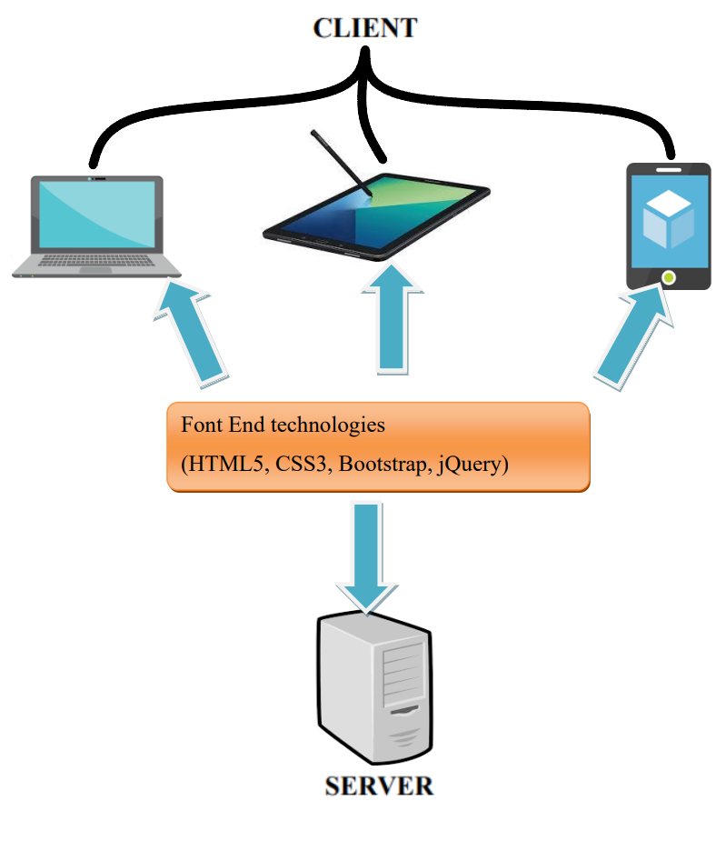

## **Sitemap**

**Website**

**Address**

**Hotline**

**Log In**

**Register**

**Currency**

**Language**

**Logo**

**Home**

**Type of Tours**

**About**

**Adventure Tours**

**Beach Tours**

**Historical Tours**

**Widlife Tours**

**About Us**

**Contact Us**

## **Website Layouts**

**Here are our layouts which will show you how we brainstormed ideas for the StarTravels's websites. Because of being academic website, we tried to build them simple but useful and informative as much as possible.**

**The website is going to have several pages which include different information in the same main layout.**

### **Home**

This layout below describes how we create a Home page containing three important parts:

***- Page title bar and navigation bar:***

The page title must have an address, hotline and other links such as Log In and Register, language conversion and currency conversion functions are optional.

The navigation bar is one of the most important parts of the entire site that will tell people how they interact with us. It must have the StarTrvels’s logo and provide some information such as search bar, Homepage, Type of Tour and Introduction. Each section must have brief information.

***- Content:***

This section is customized to the title of individual websites, Especially, Home page includes introduction and some description about StarTravels’s products.

***- Footer:***

The final part of all our websites is definitely Footer which will reveal some convenient ways to contact the support switchboard in various social channels like Hotline, Facebook, Twitter, Email, Instagram,... and summarizes the layout of the Website.

**About Us**

**Resources**

**Company**

**Contact Us**

**Hotline**

**Address**

**Log In**

**Register**

**Currency**

**Language**

**StarTravels’s Logo**

**Home**

**Type of Tours**

**About**

**Adventure Tours**

**Beach Tours**

**Historical Tours**

**Widlife Tours**

**OwlCarousel**

Image

Image

Image

Introduced some products of each Type of Tours

Address

Email

Hotline

Some information

Contact method

(Ex: Facebook, …)

**Footer**

Contact Us

Log In

Register

Home

Type of Tours

1.1 Home

### **Informative pages of Adventure Tours, ….**

The layout below describes how we create the Adventure Tours page, .... And they all contain the following three important parts:

* ***Page title bar and navigation bar:***

This section here looks like the Home page.

* ***Content:***

This section includes 2 main components: the left toolbar and the main content bar on the right.

* *The left toolbar:*

The left toolbar includes a number of utilities such as sorting by filters, actual videos, and customer support hotlines as needed.

* *The main content bar:*

The main content bar on the right includes a list of products available to customers. Each product must have summary information such as: logo image, price, rating, number of people allowed, ...

* ***Footer:***

This section here looks like the Home page.

**Resources**

**About Us**

**Company**

**Contact Us**

**Hotline**

**Address**

**Log In**

**Register**

**Currency**

**Language**

**StarTravels’s Logo**

**Home**

**Type of Tours**

**About**

**Adventure Tours**

**Beach Tours**

**Historical Tours**

**Widlife**

Address

Email

Hotline

Some information

Contact method

(Ex: Facebook, …)

**Footer**

Contact Us

Log In

Register

Home

Type of Tours

**Left Toolbar**

Sort by filter

Actual video

Hotline

**The main content bar**

Product

Product

Product

Product

Product

Product

Product

Product

Product

2.1 Adventure Tours, …

### **Detail Tour for all Tours**

This layout below describes how we create a Detail Tour page containing three important parts:

* ***Page title bar and navigation bar:***

This section here looks like the Home page.

* ***Content:***

This section includes 2 main components: the left toolbar and the main content bar on the right.

* *The left toolbar:*

The left toolbar includes the tour registration form, the actual video and customer hotline when needed.

* *The main content bar:*

The main content bar on the right includes a photo slide about the product, time and travel itinerary.

* ***Footer:***

This section here looks like the Home page.

**Resources**

**About Us**

**Company**

**Contact Us**

**Hotline**

**Address**

**Log In**

**Register**

**Currency**

**Language**

**StarTravels’s Logo**

**Home**

**Type of Tours**

**About**

**Adventure Tours**

**Beach Tours**

**Historical Tours**

**Widlife Tours**

Address

Email

Hotline

Some information

Contact method

(Ex: Facebook, …)

**Footer**

Contact Us

Log In

Register

Home

Type of Tours

**Left Toolbar**

Registration Form

Actual video

Hotline

**The main content bar**

Slide Image

Time

Schedule

3.1 Detail Tour

### **About Us and Contact Us**

These two sections also have 3 main sections like the home page:

* ***Page title bar and navigation bar:***

This section here looks like the Home page.

* ***Content:***

#### About Us:

About Us content includes the banner bar to advertise the website, introduce the formation of the Website, and view the Website on Google Maps.

#### Contact Us:

The Contact Us content section includes a simple consultation registration form and some additional information.

* ***Footer:***

This section here looks like the Home page.

**About Us**

**Resources**

**Company**

**Contact Us**

**Hotline**

**Address**

**Log In**

**Register**

**Currency**

**Language**

**StarTravels’s Logo**

**Home**

**Type of Tours**

**About**

**Adventure Tours**

**BeachTours**

**Historical Tours**

**Widlife Tours**

Address

Email

Hotline

Some information

Contact method

(Ex: Facebook, …)

**Footer**

Contact Us

Log In

Register

Home

Type of Tours

Banner

Introduce the formation of the Website

See Us on Maps

4.1 About Us

**About Us**

**Resources**

**Company**

**Contact Us**

**Hotline**

**Address**

**Log In**

**Register**

**Currency**

**Language**

**StarTravels’s Logo**

**Home**

**Type of Tours**

**About**

**Adventure Tours**

**Beach Tours**

**Historical Tours**

**Widlife Tours**

Address

Email

Hotline

Some information

Contact method

(Ex: Facebook, …)

**Footer**

Contact Us

Log In

Register

Home

Type of Tours

A simple consultation Registration Form

Some additional information

4.2 Contact Us

## **Task Sheet 1**

|  |  |  |  |  |  |  |  |
| --- | --- | --- | --- | --- | --- | --- | --- |
| **Project Ref. No.** | | **Project Title** | **Activity**  **Plan**  **Prepared**  **by** | **Date of Preparation of Activity Plan** | | | |
| **Sr. No** | **Task** | **Actual Start**  **Date** | **Actual**  **Days** | **Teammate**  **Names** | **Status** |
| 1 | Create header for all pages | PLEASANT TOURS | Lam | 9/9/2019 | 1 | Lam | Completed |
| 2 | Create Navigation bar for all pages | PLEASANT TOURS | Lam | 9/9/2019 | 1 | Lam | Completed |
| 3 | Create Offcanvas menu | PLEASANT TOURS | Lam | 9/10/2019 | 1 | Lam | Completed |
| 4 | Create Content of Home page | PLEASANT TOURS | Lam | 9/10/2019 | 2 | Lam | Completed |
| 5 | Add introduction carousel to Home page | PLEASANT TOURS | Lam | 9/12/2019 | 1 | Lam | Completed |
| 6 | Register to receive Latest Newsletter for all pages | PLEASANT TOURS | Lam | 9/13/2019 | 1 | Lam | Completed |
| 7 | Create Footer for all pages | PLEASANT TOURS | Lam | 9/13/2019 | 1 | Lam | Completed |
| 8 | Disable browser from jumping up top when clicking empty(# or “”) links for all pages | PLEASANT TOURS | Lam | 9/13/2019 | 1 | Lam | Completed |
| 9 | Create About Us page | PLEASANT TOURS | Lam | 9/14/2019 | 1 | Lam | Completed |
| 10 | Create Contact Us page | PLEASANT TOURS | Lam | 9/14/2019 | 1 | Lam | Completed |
| 11 | Create Adventure Tours page | PLEASANT TOURS | Lam, Tan, Dung, Minh | 9/15/2019 | 1 | Lam | Completed |
| 12 | Create Beach Tours page | PLEASANT TOURS | Lam, Tan, Dung, Minh | 9/15/2019 | 1 | Lam | Completed |
| 13 | Create Detail Tours page for all Type of tours | PLEASANT TOURS | Tan | 9/9/2019 | 7 | Tan | Completed |
| 14 | Find information 10 tours | PLEASANT TOURS | Dung, Minh | 9/11/2019 | 4 | Dung, Minh | Completed |

|  |  |
| --- | --- |
| Signature of Faculty | Signature of Leader Team |
|  |  |

# **REVIEW 2**

## **Website Interface**

### **Homepage**

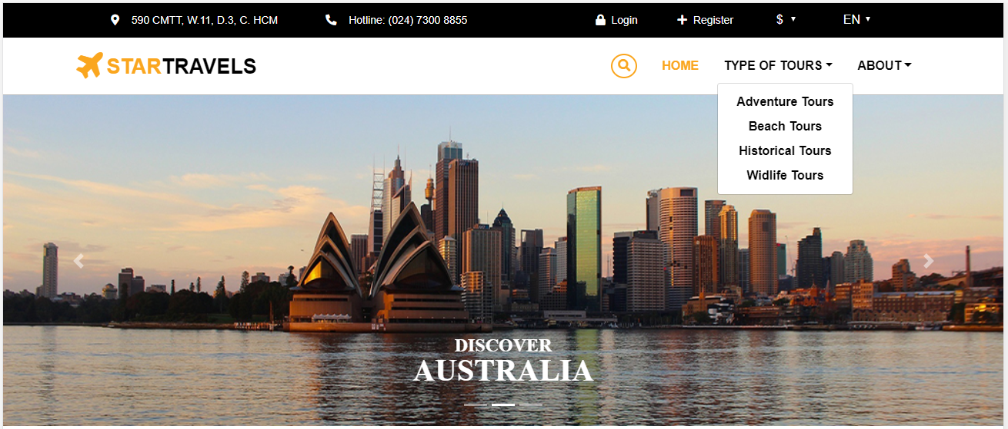

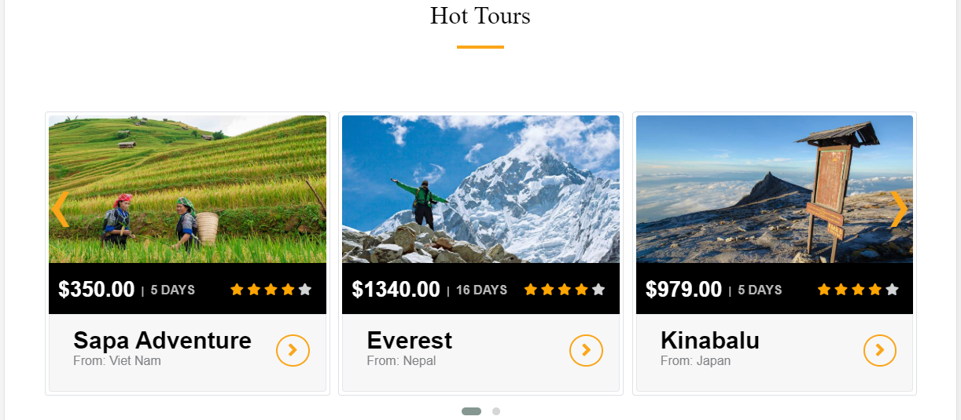

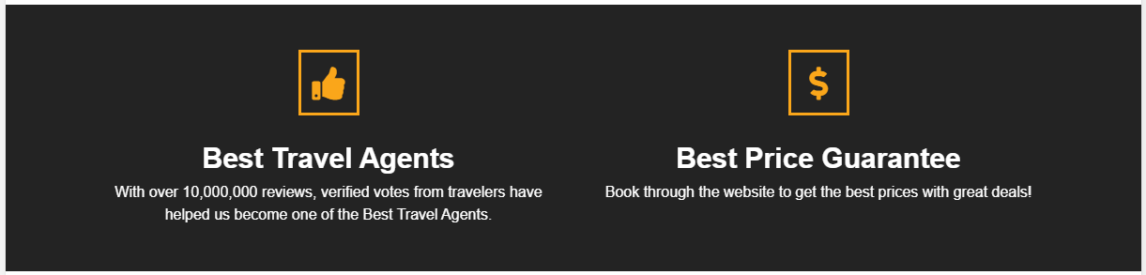

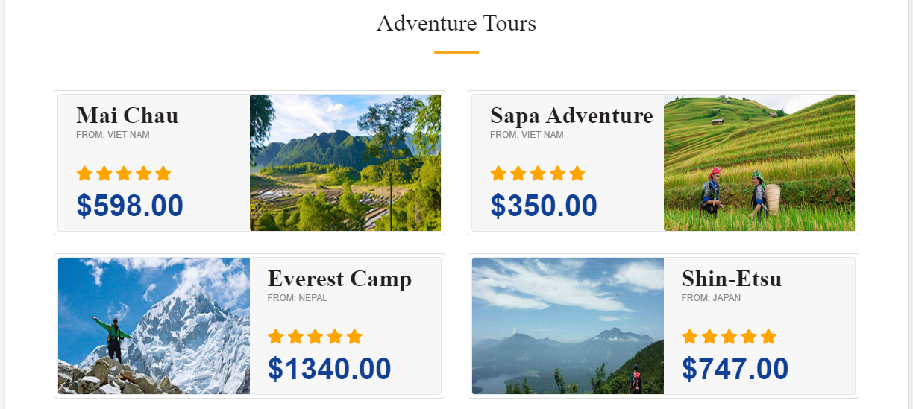

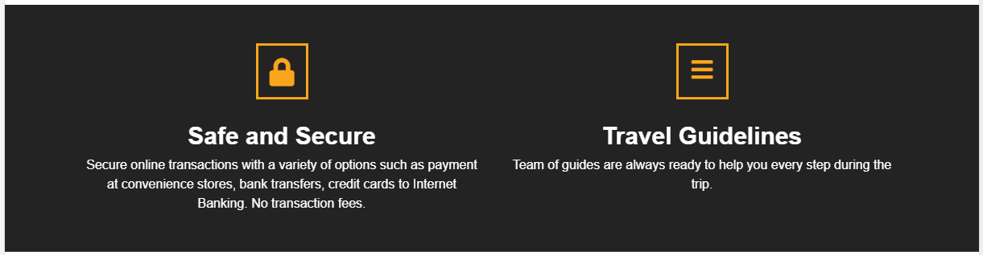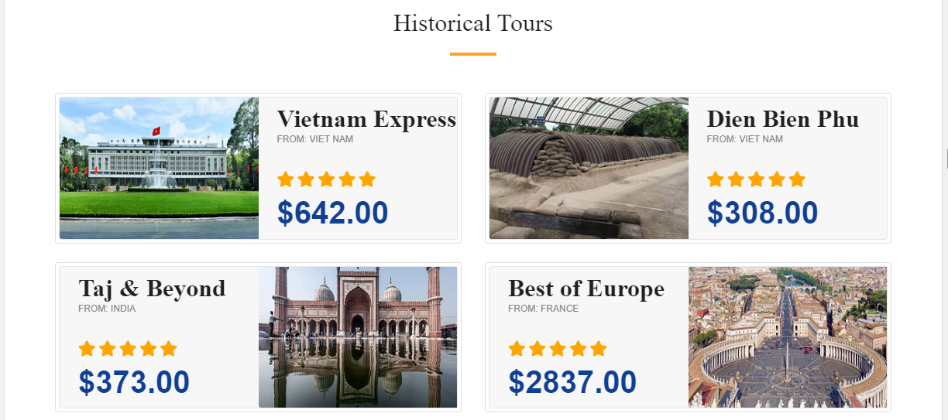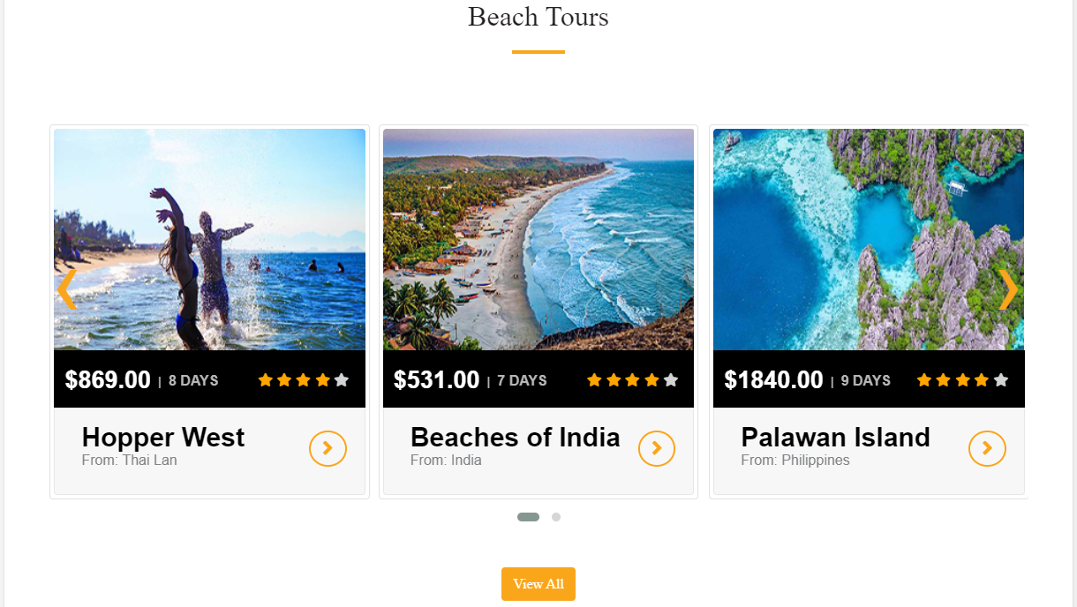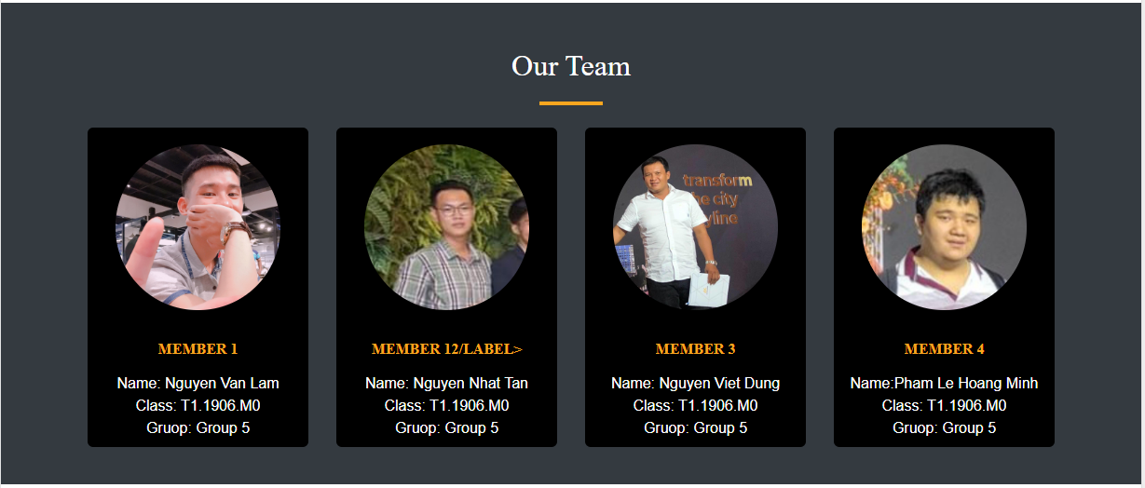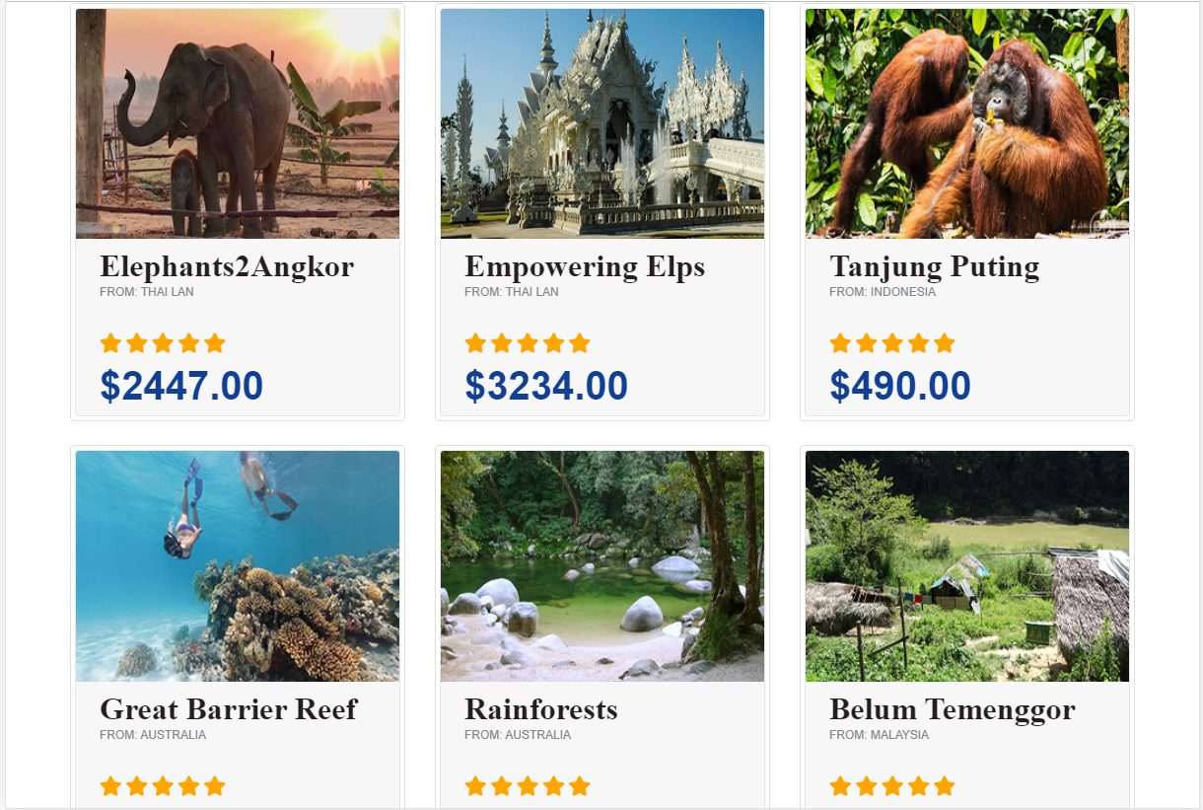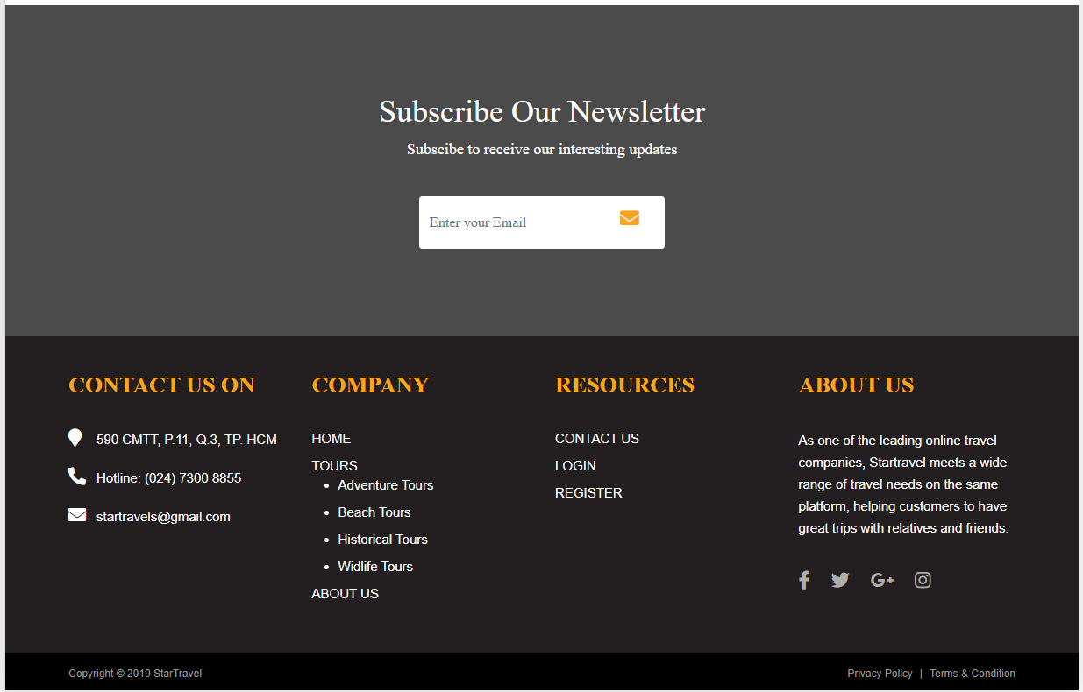

When patients and visitors click the navigation bar, a menu bar will appear with its links as you see above picture.

|  |  |
| --- | --- |
| **Title** | **Description** |
| Home | * Carousels which show some highlights about some countries. * Introducing some of the hottest tours. * Introducing some typical tours of each type of tour (Beach Tours, Adventure Tours, Widlife Tours, Historical Tours,..) * Some information of my group, and have video review. * Footer with different ways to contact us and some related associations. |
| Type of Tour | * Includes list of tour types * Beach Tours * Historical Tours * Adventure Tours * Widlife Tours |
| About | * Contact Us: * StarTravels’s address with map, main contact. * About Us: * About Us has a big banner ad to attract customers. * Introduction about the startravels's establishment and development. * And it also has an address map |

### **Contact Us Page**

When you click the Contact us link in the About section, this page below will show you the map to the hospital with the geolocation API and key contact information. You can also contact our members directly via some social networks or email.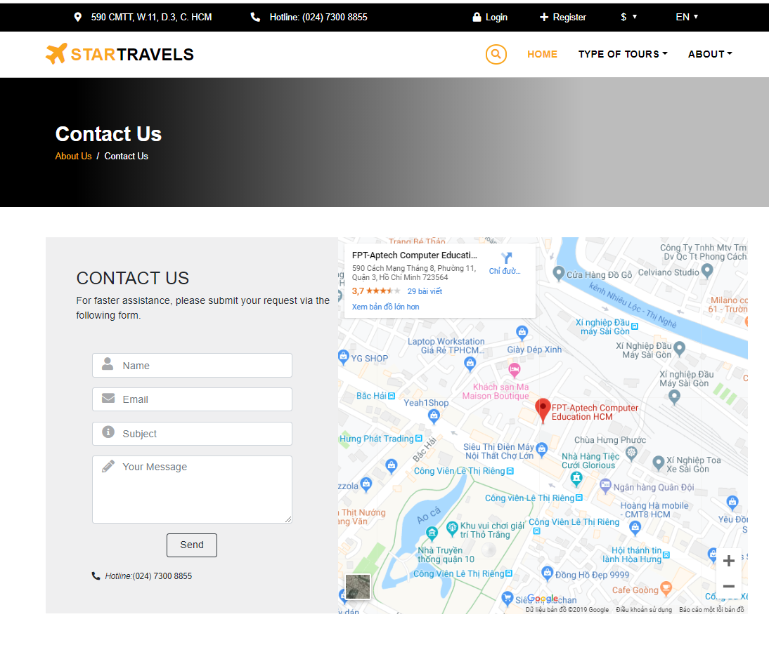

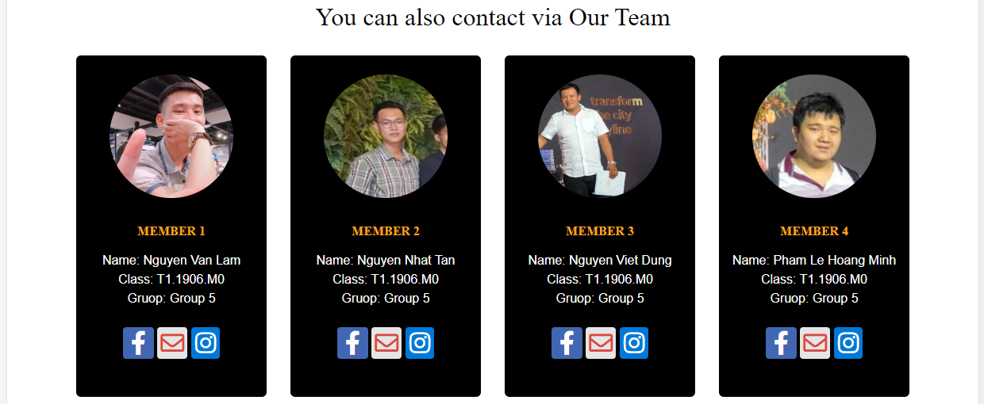

### **About Us**

When you click the About Us link in the About section, this page below will show you a fairly large banner at the top of the page.

Introduction about the startravels's establishment, development and information of Company.

And there is also a map, like the Contact Us, that leads to our headquarters with the geolocation API and the main contact information.

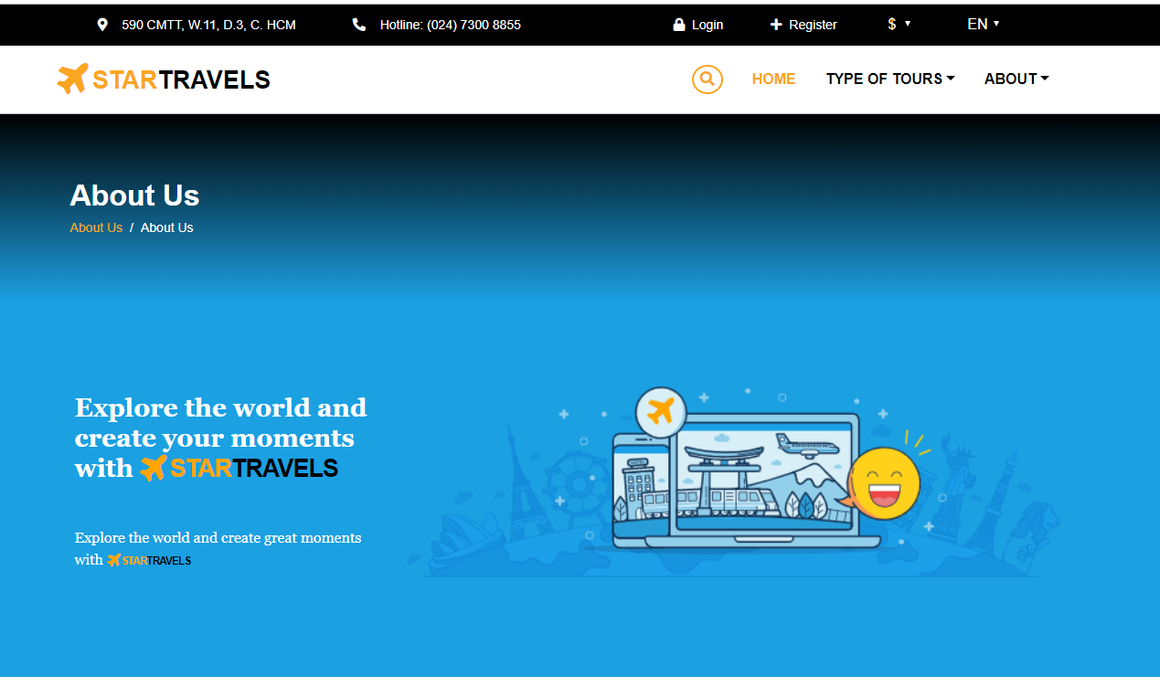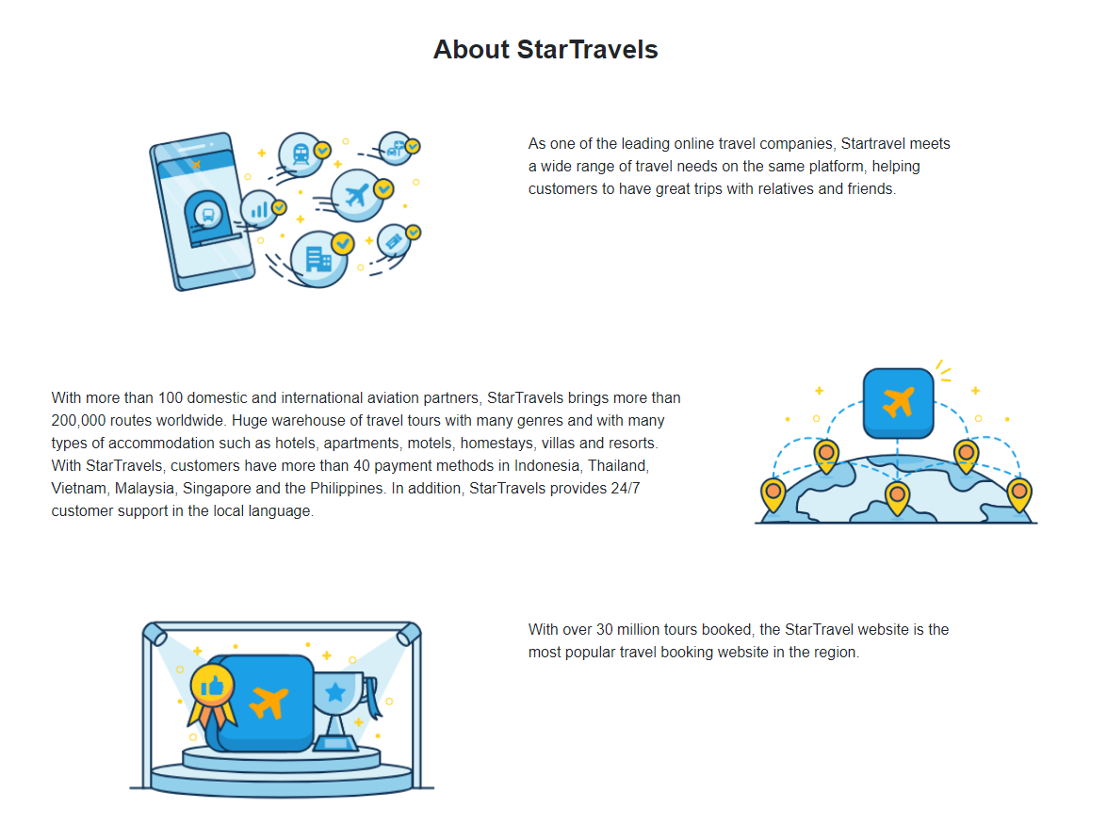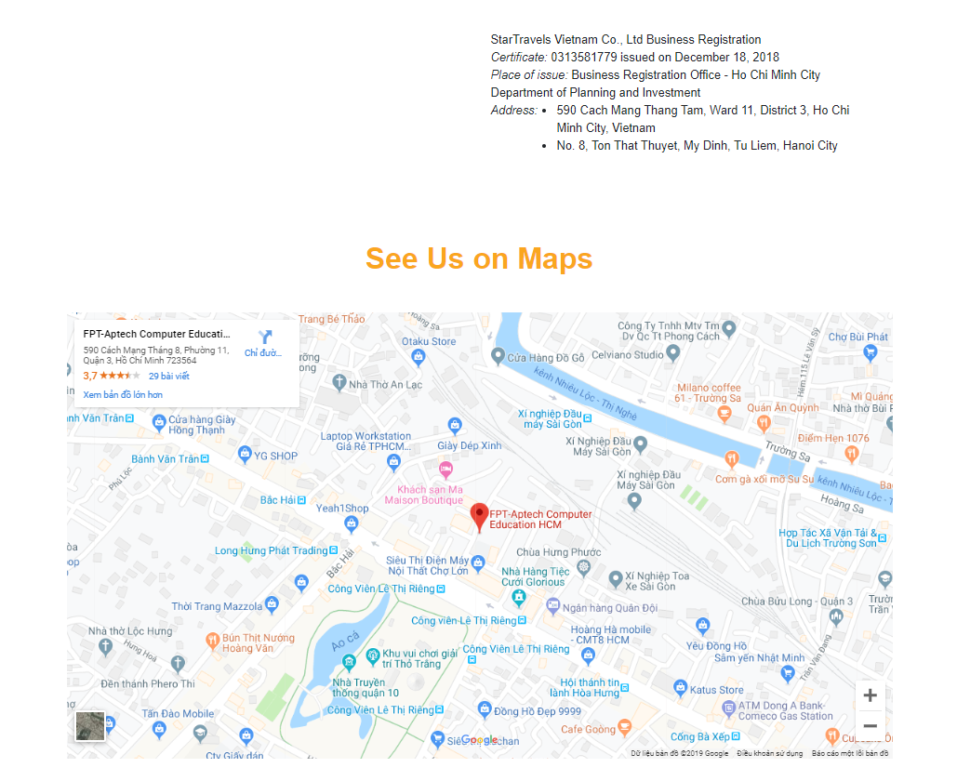

### **Type Of Tour**

* In this section, whenever customers click on "Type Of Tours", passengers will see a list of interesting types of tourism appear.

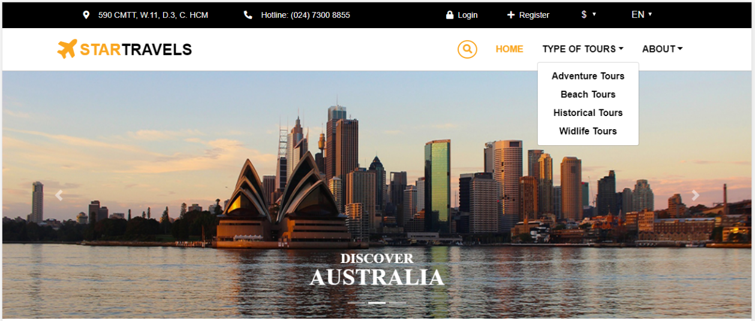

* The last part in this section, which is also the most important part, is interesting, and furthermore I believe that you will be inspired by adventure trips like Adventure Tours or Widlife Tours, and have There are also cruises for those who like to relax and relax with family or friends like Beach Tours, in addition to a variety of historical discovery tours (Historical Tours). Moreover, the price
* The images below will show you that what we say is absolutely true.

**Adventure Tours**

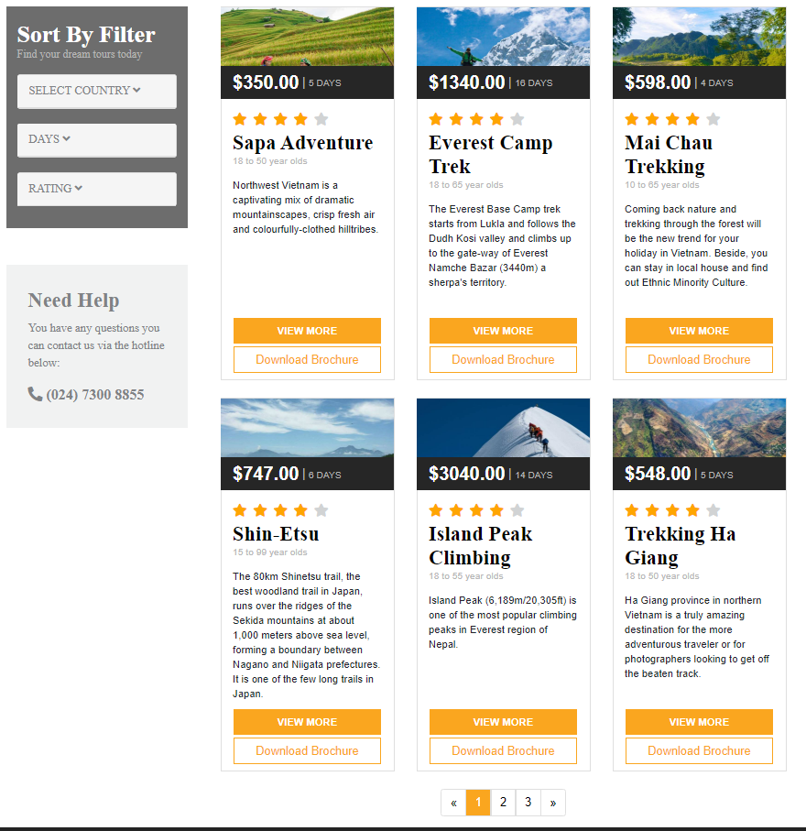

* In addition, you can contact us via the hotline that we provide right in the type of tours

### **Footer**



In the image above you will see two separate items.

* First item - subscribe to the latest news:
* When you click on the email icon as shown in the picture, a new email window will pop up to send you a confirmation to agree to receive news via email.

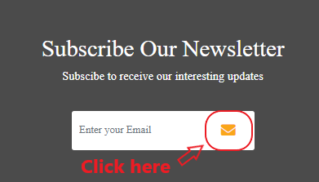

* After clicking immediately, the table will appear as the following image:

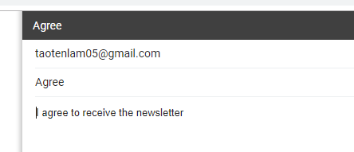

* Second item - main footer item:
* It includes everything such as contact methods, addresses, referrals and copyright.

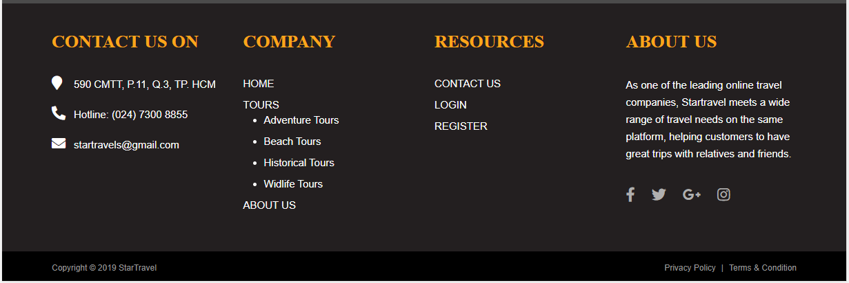

## **Time Management**

**STAGE 3 (Sep 22th – Oct 5th)**

* Edit and complete website
* Test in different browsers and monitor sizes
* Write Final Project Report

**STAGE 2 (Sep 12th – Sep 22th)**

* Collect images, details
* Build webpages (HTML, CSS, JS)
* Group to website with links
* Write Project Report

**STAGE 1 (Sep 9th – Sep 12th)**

* Ideas discussion
* Create layouts for website
* Search for general information for all pages

## **Task Sheet 2**

|  |  |  |  |  |  |  |  |
| --- | --- | --- | --- | --- | --- | --- | --- |
| **Project Ref. No.** | | **Project Title** | **Activity**  **Plan**  **Prepared**  **by** | **Date of Preparation of Activity Plan** | | | |
| **Sr. No** | **Task** | **Actual Start**  **Date** | **Actual**  **Days** | **Teammate**  **Names** | **Status** |
| 1 | Fix send email of Subcribe Our Newsletter | Pleasant Tours | Lam | 9/12/2019 | 1 | Lam | Completed |
| 2 | Find more information of each tours | Pleasant Tours | Minh, Dung | 9/12/2019 | 7 | Minh, Dung | Completed |
| 3 | Add information of each tour into the web | Pleasant Tours | Lam | 9/13/2019 | 5 | Lam | Completed |
| 4 | Create Historical Tours page | Pleasant Tours | Lam | 9/17/2019 | 1 | Lam | Completed |
| 5 | Create Widlife Tours page | Pleasant Tours | Tan | 9/18/2019 | 1 | Tan | Completed |
| 6 | Find and fix some Error | Pleasant Tours | Lam | 9/19/2019 | 3 | Lam | Completed |
| 7 | Create Beach Widlife Tours page | Pleasant Tours | Tan | 9/20/2019 | 1 | Tan | Completed |
| 8 | Create Beach Historical Tours | Pleasant Tours | Lam | 9/20/2019 | 1 | Lam | Completed |
| 9 | Create Pdf Download for all Tours | Pleasant Tours | Lam | 9/21/2019 | 1 | Lam | Completed |
| 10 | Group pages together  with links and update  information | Pleasant Tours | Lam | 9/22/2019 | 3 | Lam | Completed |
| 11 | Test website in  different browsers | Pleasant Tours | Lam | 9/24/2019 | 4 | Lam | Completed |
| 12 | Write Project report 2 | Pleasant Tours | Lam | 9/26/2019 | 3 | Lam | Completed |

|  |  |
| --- | --- |
| Signature of Faculty | Signature of Leader Team |
|  |  |

## **Checklist Validation**

|  |  |  |
| --- | --- | --- |
| **Task No.** | **Requirment** | **Validation** |
| 1 | The Home Page should be created making use of Frames with a suitable logo. | Yes |
| 2 | The site should display a menu which will contain the options for brief introduction about the various products available, location of the shop and any other information if required. | Yes |
| 3 | The information should be categorized according to different type of products like if a User wants to see only ‘Beach Tours’ then he click on a Link/button/menu etc and he will see different type of Beach Tours. Similarly  for ‘Hill Stations’, ‘Forts/Palaces’ and other products | Yes |
| 4 | When a user selects any product type, a list of products for that product type will be displayed. | Yes |
| 5 | Itinerary of individual tour products should be displayed on the Web Page along with the title but detailed itinerary should be stored in Individual Word documents which can be downloaded or viewed by the User who wishes to  see the same. | Yes |
| 6 | Price List for all tours should be available for download. | Yes |
| 7 | There should be a “Contact Us” page which will have the Address of the Company which is as follows and the mail address which when clicked will invoke the local mail client from where they can send an email. Address of the  Company should be displayed using GeoLocation API (eg. GoogleMaps). | Yes |

## **Referrence**

1. **Get information tours:**

<https://www.tourradar.com/t/10320#p=1_>